**Git Repository**

1. **Create a repository :**

* Go to [https://github.com](https://github.com" \t "_new)
* Click the **+** icon in the top-right corner → **New repository**
* Fill in:

1. Repository name
2. (Optional) Description
3. Choose **Public** or **Private**
4. Initialize with **README** (optional)

* Click **Create repository**

1. **Copy the Repository URL**

* Once the repository is created, click the **green "Code" button**
* Copy the **HTTPS** URL (e.g., <https://github.com/yourusername/your-repo.git)>

1. **Clone the Repository into a Local Project Folder**

* Open your terminal (Command Prompt, Git Bash, or Terminal)
* Navigate to the directory where you want to store your project:





* Clone the repository:





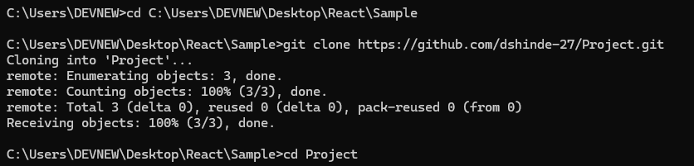

1. **(Optional): Start Working :**

* git add .
* git commit -m "Initial commit"
* git push origin main

